Day | Date | Safari Experience
Friday | 8/2 | Arrival
Saturday | 8/3 | Village Tour/Free Time
Sunday | 8/4 | Game Drives
Monday | 8/5 | Visit Schools Village Shops
Tuesday | 8/6 | Game Drives
Wednesday | 8/7 | Village Activity Optional Spa
Thursday | 8/8 | Village Activity
Friday | 8/9 | Village Activity
Saturday | 8/10 | Game Drives
Sunday | 8/11 | Departure
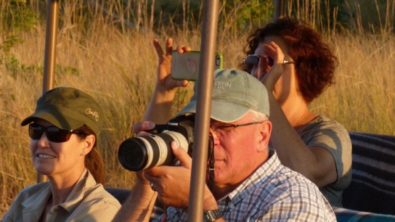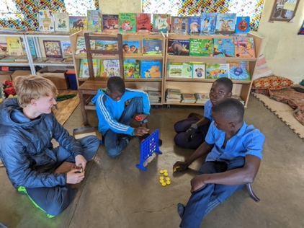
Village Activities include: Reading Center Visits, Chipembele Visits, Detection Dog Demo at Conservation South Luangwa (CSL), Jewelry making at Mulberry Mongoose, Art Safari at Tribal Textiles, Zambian Carnivore Program (ZCP) tour, soccer game, Project Luangwa Leadership Experience, Borehole Tour, Bush Spa, Additional Game Drives

